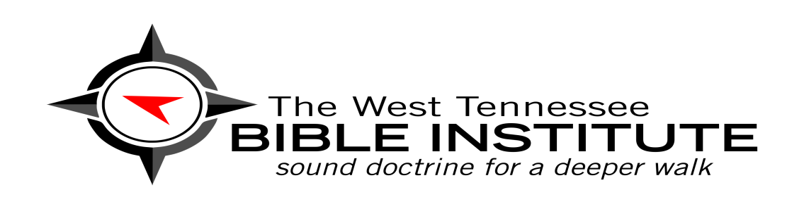

We carry our Bibles back and forth to church on Sunday, but how well do we really *know* our Bibles? When we get that knock at the door and we peer through our windows to see who it is, do we slowly back away and keep quiet when it’s a Jehovah’s Witness or a Mormon? The Carroll-Benton Baptist Association is opening the new *West Tennessee Bible Institute* where lay-leaders, church members, bi-vocational and interim pastors, who haven’t received previous Bible training, can all receive a Bible College experience in a short period of time and for a very low-rate. This Institute is the very first of its kind in our state!

In high school and college we had difficult courses to complete: Biology, Chemistry, Physics, and Arithmetic. We completed those courses because we wanted to graduate. But unfortunately, the most important subject and Book that holds promise not only for this present life but for eternity is one of the most neglected. In many of our homes the Bible collects dust from one Sunday to the next. How sad! It contains *eternal truths* which determine *eternal destinies*. If there is any book worthy of our utmost diligence in study, it’s the Bible!

When I came as your Director of Missions I wanted to begin a “Bible College for the average Joe (or Jane) where the truths of Scripture would be placed on the bottom shelf”. I wanted to make the rich treasure of Scripture understandable to the man/woman in the pew. Even if you’ve been in church all your life, there’s only a certain number of truths your pastor is able to cover in one 30-40 minute sermon.

The *West Tennessee Bible Institute* is designed for every member of every church in our association. Others outside our association are also welcome, but need to understand that we will teach in strict accordance to the *Baptist Faith and Message*. Let me give you a quick run-down of how the Institute will operate:

* There are 4 major courses to complete to receive your **Diploma in Christian Studies**. We will offer 2 classes per semester. Each class will meet every other week so that you have plenty of time for your reading assignments. The first class, **Introduction to the Bible and Bible Doctrine**, will begin Tuesday, Sept. 4, from 6:30-8pm. It won’t meet again until 2 weeks later, Sept. 18, at the same time and same place (the CBBA office in Huntingdon). Every class will operate on this every-other-week schedule. The next class, **Introduction to the Cults and False Religions**, will begin on Sept. 11 (same time/place), and meet again 2 weeks later on Sept. 25. Both classes will continue meeting every-other-week until the end of the semester in mid-December. (Since there are only 4 courses to complete, and they meet every other week, you could finish your Diploma in 2 semesters, the fall and spring.. just one year!).
* If there are certain courses that peek your interest more than others, no problem. For each class finished, you will receive a **“Certificate of Completion”** from the *West Tennessee Bible Institute.*
* Each class will be taught by a pastor within the CBBA or the DOM who have completed seminary and earned either their Doctor’s or Master’s degree.
* Second semester classes will begin in January and include **Introduction to the Spiritual Disciplines** (this is where the “rubber meets the road”- where the truths you’ve learned are taught to be lived out) and **Apologetics** (how to answer those who have questions regarding our faith- how do you know the Bible is true? How can you believe in God? Doesn’t the Bible contradict science? Etc..)
* In addition to earning your **Diploma in Christian Studies**, if any of our men feel God may be calling them to preach and lead a congregation, next fall you may take an additional course, **Introduction to Expository Preaching and Pastoral Ministry**, and graduate with a **Diploma in Christian Studies with Preaching and Pastoral Ministries.** This would be perfect for those who feel God may be grooming them for interim or bi-vocational ministry.

These classes will be on-going each year, so don’t feel rushed to get them all done at once. We will offer the same classes next year until you finish your Diploma. And here’s the really cool thing- each class is only $20! You may call our office, register by phone, and pay your fee the night of the first class. Each student must have their own textbook. You will need to purchase these yourself and bring them to the first class. Lifeway Bookstore in Jackson carries each of these books if you don’t order online. For the course **Introduction to the Bible and Bible Doctrine** the textbook will be 50 Core Truths of the Christian Faith by Gregg Allison, and for the course **Introduction to the Cults and False Religions** the textbook is The Compact Guide to World Religions by Dean Halverson.

One more thing: did you notice the tag line right under the name of our school? “Sound Truth for a Deeper Walk”. The goal of our school is not just a bunch of head knowledge, but a heart that’s fully committed to pursuing Jesus. May that be the prayer for all who love and follow Christ. May the truth that sounds forth via this Institute bring God the glory he deserves and may our lives not be content with shallow, half-hearted Christianity, but may we be radical, sold-out disciples of our Lord Jesus Christ!